**DAILY ONLINE ACTIVITIES SUMMARY**

|  |  |  |  |  |  |  |  |  |
| --- | --- | --- | --- | --- | --- | --- | --- | --- |
| **Date:** | **24/06/2020** | | | | | **Name:** | **Shailashree** | |
| **Sem & Sec** | **IV sem & B section** | | | | | **USN:** | **4AL18CS077** | |
| **Online Test Summary** | | | | | | | | |
| **Subject** | | **-** | | | | | | |
| **Max. Marks** | | **30** | | **Score** | | | **-** | |
| **Certification Course Summary** | | | | | | | | |
| **Course** | **Blockchain Basics** | | | | | | | |
| **Certificate Provider** | | | **Great learning academy** | | **Duration** | | | **2.5hours** |
| **Coding Challenges** | | | | | | | | |
| **Problem Statement1:** Given a 2D array arr[][] of size M x N integers where M is the number of rows and N is the number of columns. The task is to reverse every row of the given 2D array. | | | | | | | | |
| **Status: Executed** | | | | | | | | |
| **Uploaded the report in GitHub** | | | | | **yes** | | | |
| **If yes Repository name** | | | | | **Lockdown coding** | | | |
| **Uploaded the report in slack** | | | | | **yes** | | | |

Online Test Summary: No internals conducted today.

Online Certification Course Summary: In today’s session I have learnt about the Accounts, Blocks, Transactions and Merkle Tree.

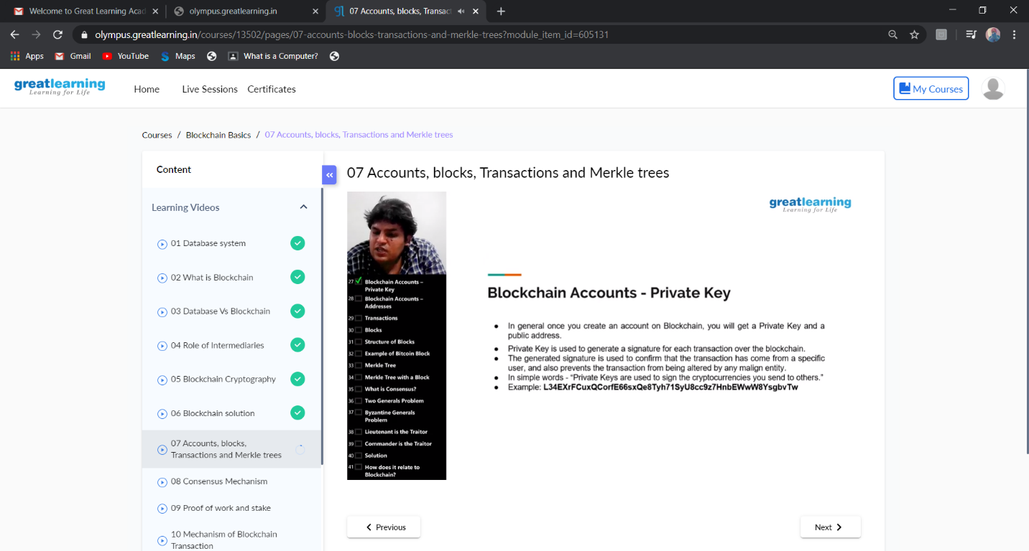

This is the snap shot of today’s session.

Online Coding Summary: **Today I had received one program from prof. Shilpa Hassan CSE Dept. The program is mentioned above in the coding challenges(pg.01). I have also uploaded it to my GitHub repository.**

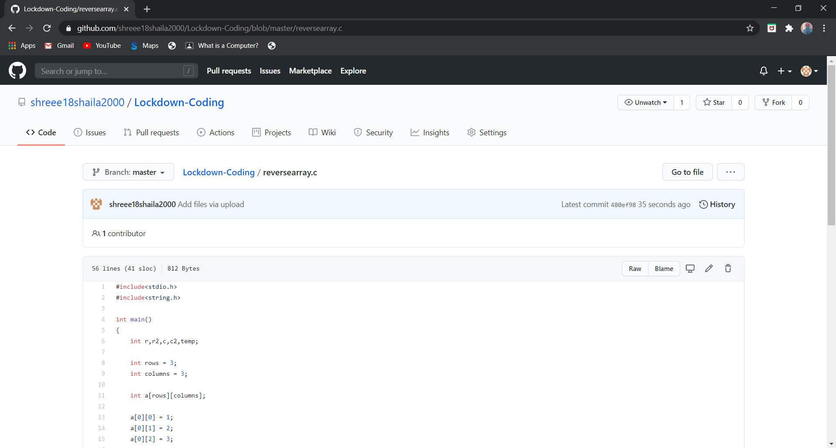

Online Training: Today I had attended the online training organized by CSE Department AIET. The training was on C programming done by Prof. Megha D. Hegde CSE Dept. After the session the quiz was conducted.

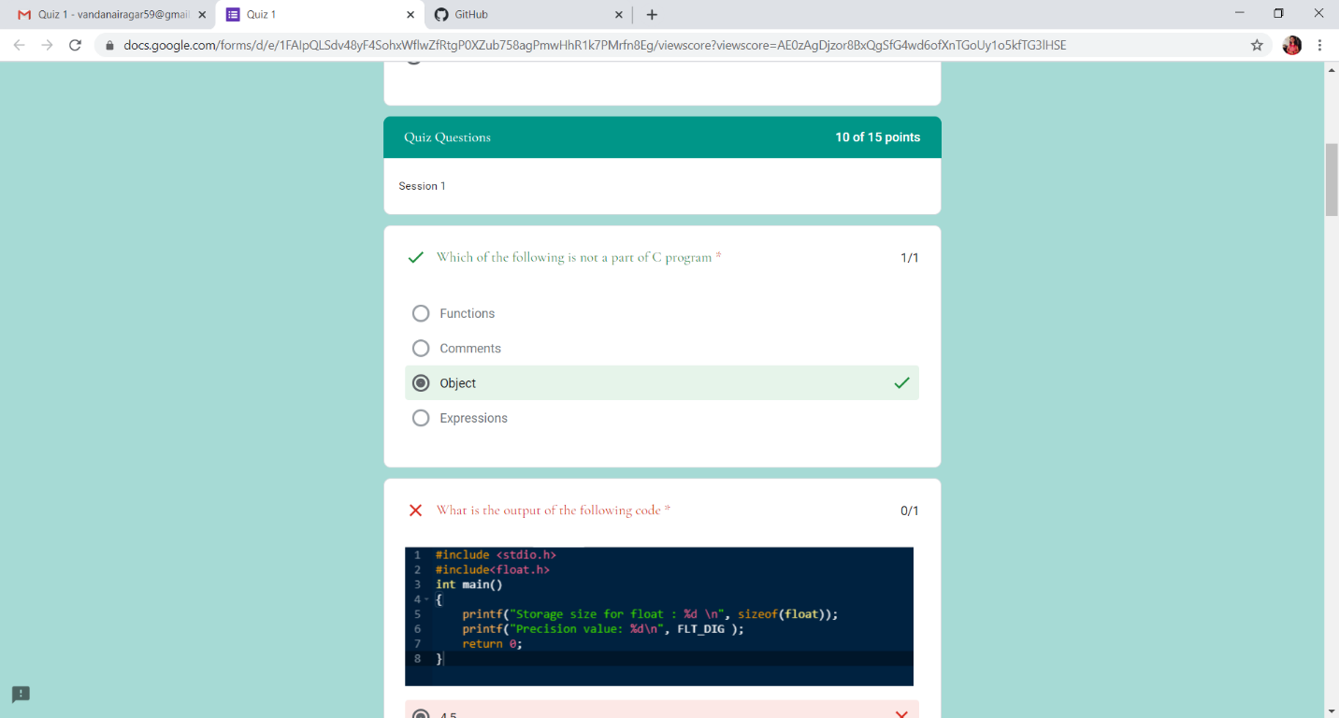

**This is the snap shot of the quiz attempted and the marks obtained.**